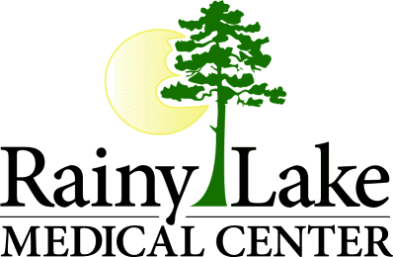 Summary of Rainy Lake Medical Center’s Financial Assistance Policy
Plain Language Summary

Rainy Lake Medical Center’s Financial Assistance Program (Community Care program & Sliding fee scale discount) provides free or reduced cost healthcare to patients who are unable to pay fully for services received at our facility dependent on income guidelines.

Availability of Financial Assistance and Coverage
- You can ask for help with your bill at any time during your visit or billing process. You may be able to receive financial assistance if you do not have insurance, are underinsured, or having a financial hardship for services at Rainy Lake Medical Center.
- Services covered are those that are medically necessary and provided to you by Rainy Lake Medical Center’s staff and billed by Rainy Lake Medical Center. Services that would not be covered are cosmetic or elective procedures and services provided by outreach providers that would bill separately such as radiologists and cardiologists.

Obtaining an Application / How to apply
- Printable application is available on our website, www.rainylakemedical.com, click Resources at top of home page, click Financial Information, scroll down to Assistance is available to links for printable application and checklist, or contact a Financial Counselor to mail you an application.
- If you need help with the application process, call to setup an appointment with our Financial Counselors to apply in-person. We would be happy to assist you. You are responsible for providing information timely about your health benefits, income and other paperwork required.
- Rainy Lake Medical Center staff will uphold the confidentiality and dignity of each patient, and any information submitted for consideration of financial assistance will be treated as protected health information under the Health Insurance and Portability and Accountability Act (HIPAA)
- Mail applications to: Rainy Lake Medical Center / Attention: Financial Counselors / 1400 Highway 71 / International Falls, Minnesota 56649
- Fax applications to: 218-598-5128
- Phone numbers: 218-283-5300 or 218-283-5414
- Office hours for our Financial Counselors: 8:00 am – 4:30 pm central standard time (located on our hospital campus)

No more than Amount Generally Billed (AGB)
- No person eligible for Financial Assistance under the financial assistance plan will be charged more for emergency or medically necessary care than the amount generally billed to patients who have insurance coverage for such care.

Eligibility
- Eligibility is based on your income and your application for, and use of, any private or government health care coverage available to you. Once criteria are met, our program may assist you with unpaid bills, including those resulting from insurance deductibles and co-payments.
Financial Assistance eligibility is divided into three categories based on income:
- Any person who qualifies under the guidelines and income is at or below 200% of the Federal poverty level (updated annually), adjusted for family size is entitled to care at no cost.
- Any person whose income is more than 200% but not more than 300% of the Federal poverty guidelines (updated annually), adjusted for family size is entitled to a reduced cost based on the sliding fee scale (updated annually as the federal poverty guidelines change) established by Rainy Lake Medical Center and approved by the Board of Trustees.
- Any person whose income exceeds 300% of the Federal poverty guidelines (annually updated), adjusted for family size may be eligible for reduced cost if their income is not sufficient to enable them to fully pay for the services. It is the determination of Rainy Lake Medical Center to reduce charges.
For Non- English Speakers
- Rainy Lake Medical Center provides interpreters upon request of the patient or patient’s companion to accommodate either language or disability needs.

