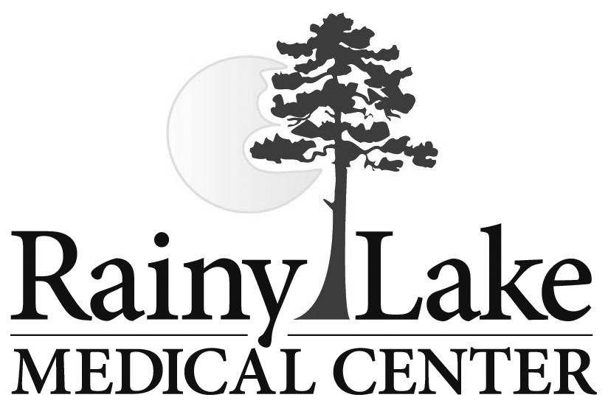

Please note the following information regarding certain services at Rainy Lake Medical Center:

- If you receive any Radiological test or procedure, such as Xray/ CT scan/ MRI, you will receive a bill from the Radiologist’s office that would interpret the test or perform the procedure. Rainy Lake Medical Center does not bill for these professional services.
- If you receive Cardiac services, such as Stress testing, etc., and it requires a Cardiologist to interpret the test, you will receive a bill from that Cardiologist’s office for that service. Rainy Lake Medical Center does not bill for these professional services.
- Notice to our United Healthcare subscribers: Due to a contractual agreement with United Healthcare, any laboratory testing that would need to be sent out to Sanford Medical Center (Outside laboratory used for resulting of test that RLMC is unable to process) will be billed to your insurance plan and you by Sanford Medical Center.

If you have any questions or concerns regarding the billing you receive from the other facilities (mentioned above), please refer to the phone number for that facility for billing questions from their billing statement. Rainy Lake Medical Center would not have access to that information and would not be able to assist you for any other facility’s billings.

If you have any questions or concern regarding this process or your statements from Rainy Lake Medical Center, please contact our billing department.

Please note the following information regarding certain services at Rainy Lake Medical Center:

- If you receive any Radiological test or procedure, such as Xray/ CT scan/ MRI, you will receive a bill from the Radiologist’s office that would interpret the test or perform the procedure. Rainy Lake Medical Center does not bill for these professional services.
- If you receive Cardiac services, such as Stress testing, etc., and it requires a Cardiologist to interpret the test, you will receive a bill from that Cardiologist’s office for that service. Rainy Lake Medical Center does not bill for these professional services.
- Notice to our United Healthcare subscribers: Due to a contractual agreement with United Healthcare, any laboratory testing that would need to be sent out to Sanford Medical Center (Outside laboratory used for resulting of test that RLMC is unable to process) will be billed to your insurance plan and you by Sanford Medical Center.

If you have any questions or concerns regarding the billing you receive from the other facilities (mentioned above), please refer to the phone number for that facility for billing questions from their billing statement. Rainy Lake Medical Center would not have access to that information and would not be able to assist you for any other facility’s billings.

If you have any questions or concern regarding this process or your statements from Rainy Lake Medical Center, please contact our billing department.

